What are LEDs?
LEDs, or light–emitting diodes, are semiconductor devices that produce visible light when an electrical current is passed through them. LEDs are a type of Solid State Lighting (SSL), as are organic light–emitting diodes (OLEDs) and light–emitting polymers (LEPs).

How is LED lighting different than other light sources, such as incandescent and CFL?
LED lighting differs from incandescent and compact fluorescent lighting in several ways. When designed well, LED lighting can be more efficient, durable, versatile and longer lasting.
LED lighting products use light emitting diodes to produce light very efficiently. An electrical current passed through semiconductor material illuminates the tiny light sources we call LEDs. The heat produced is absorbed into a heat sink.
Common LED colors include amber, red, green, and blue. There is actually no such thing as a “white” LED. To get white light the kind we use for lighting our homes and offices, different color LEDs are mixed or covered with a phosphor material that converts the color of the light. The phosphor is the yellow material you can see on some LED products. Colored LEDs are widely used as signal lights and indicator lights, like the power button on a computer.
LEDs are now being incorporated into bulbs and fixtures for general lighting applications. LEDs are small and provide unique design opportunities. Some LED bulb solutions may look like familiar light bulbs and some may not but can better match the performance of traditional light bulbs. Some LED light fixtures may have LEDs built–in as a permanent light source.
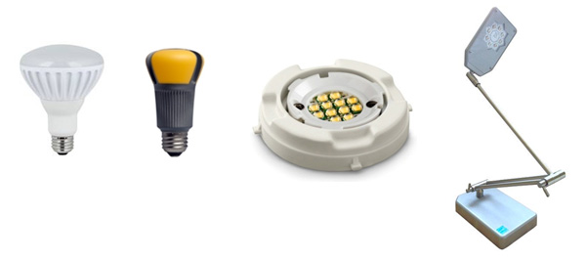
LEDs are “directional” light sources which means they emit light in a specific direction, unlike incandescent and compact fluorescent bulbs which emit light – and heat – in all directions. For this reason, LED lighting is able to use light and energy more efficiently in many applications. However, it also means that sophisticated engineering is needed to produce an LED light bulb that shines light all around like an incandescent A-shape bulb.
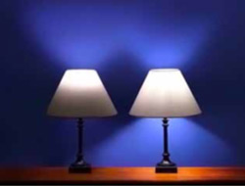LED bulbs that have earned the ENERGY STAR are subject to very specific requirements designed to replicate the experience you are used to with a standard A-type bulb, so they can be used for a wide variety of applications. As the graphic on the right demonstrates, a general purpose LED bulb that does not qualify for the ENERGY STAR may not distribute light in all directions and could prove to be a disappointment if used in a table lamp.
For more information on how to select an ENERGY STAR certified bulb for each application in your home, visit our lighting purchasing guide (1.2MB).
Incandescent bulbs produce light using electricity to heat a metal filament until it becomes “white” hot or is said to incandesce. As a result, incandescent bulbs release 90% of their energy as heat.
In a CFL, an electric current flows between electrodes at each end of a tube containing gases. This reaction produces ultraviolet (UV) light and heat. The UV light is transformed into visible light when it strikes a phosphor coating on the inside of the bulb. Learn more about how CFLs work.
LED Basics
The useful life of LED lighting products is defined differently than that of other light sources, such as incandescent or CFL. This is because LEDs typically do not “burn out” or fail. Instead, they experience lumen depreciation, where the amount of light produced decreases and light color appearance can shift over time. Instead of basing the useful life of an LED product on the time it takes for 50% of a large group of lamps to burn out (as is the case with traditional sources), LED product “lifetime” is set based on a prediction of when the light output decreases 30 percent.
LEDs and Heat
Because LED lighting systems don’t radiate heat the way an incandescent or halogen light bulb does, the heat produced from the power going into the product must be drawn away from the LEDs. This is usually done with a heat sink, which is a passive device that absorbs the heat produced and dissipates it into the surrounding environment. This keeps LEDs from overheating and burning out. Thermal management is probably the single most important factor in the successful performance of an LED product over its lifetime because the higher the temperature at which the LEDs are operated, the more quickly the light will degrade, and the shorter the useful life will be.
LED products use a variety of unique heat sink designs and configurations to manage heat, so they may look very different from each other. Regardless of the heat sink design, all LED products that have earned the ENERGY STAR have been tested to ensure that they properly manage the heat so that the light output is properly maintained through the end of its rated life.
Back to top

Why should I choose ENERGY STAR certified LED lighting products?
There are more lighting choices available on store shelves than ever before. Even with all the new choices, it’s still simple – look for the ENERGY STAR label. ENERGY STAR means high quality and performance, particularly in the following areas:
- COLOR QUALITY: Consistent white light over the rated life
- LIGHT OUTPUT: Light must meet minimum levels for replacement claims and is maintained through the end of rated life
- EFFICACY: More light (lumens) for less watts, 75% or more
- WARRANTY: 3 year minimum warranty.
All ENERGY STAR certified lighting products are subject to thorough testing and review before they can bear the label, including:
- Verified compliance with more than 20 separate industry standards and procedures
- Third–party testing of products off the retail shelf
- Rapid cycling of bulbs thousands of times to find early failures
- Testing to stress the products in operating environments similar to how you will use the product in your home
Find ENERGY STAR certified light bulbs and light fixtures.
Reprint from Energy Star-EPA Publication
www.remierlighting.com

