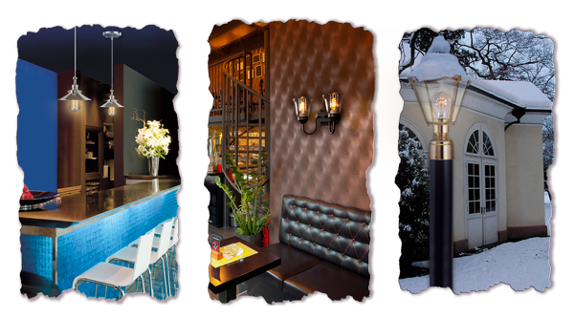

Anytown USA, Today's eclectic decors demand innovative approaches to lighting. Many design plans are calling for the look and feel of the antique lighting of yesterday, but want the energy saving and modern manufacturing technologies of today. Sunlite, a leader in the wholesale distribution of high quality lighting, has managed to marry the aesthetics of early 20th century lighting with the latest energy efficient technology to create the perfect lighting solution to meet current market trends.
Utilizing designs from the past and crafted meticulously from the finest materials, Antique Lighting, was produced to blend with a wide variety of home and office décors. The look of the early days of the light bulb, when Edison was creating what was considered the most advanced technology of the time, is beautifully replicated in this collection. The Antique Edison bulbs feature gold flecks, flame tips and retro radio styles.
All the bulbs in this collection give off the warm orange hue of yesteryear's electric lights, oil lamps and candle glow, with a color temperature of 3200 kelvin and lumen outputs varying from 40-400 lumens. The smoky finish of each bulb helps create the look of another era in kitchens, bedrooms, hallways and living rooms. The bulbs also add a touch of the true ambiance of the Victorian-era to bars, restaurants, theaters, hotels or other themed designed settings.
Customers can choose from three hand woven filaments, including spiral, thread and loop designs. These bulbs may have all the aesthetic sensibilities of bygone days, but, each one provides the lifespan of a contemporary bulb, illuminating for 2.7 years.
The bulbs are made to accent the collection's assortment of lighting fixtures. These timeless fixtures are crafted from the latest materials. Among the designs are pendant, canopy and open cage fixtures, each available in a range of styles and colors to complement modern, traditional, urban, transitional or rustic decorating schemes.
To browse the company's product catalog visit us at: www.remierlighting.com

